|  |  |  |
| --- | --- | --- |
|  | | |
|  |  | |
|  |
|  |
|  | | |
|  | |  |
| SAMSUNG ELECTRONICS RESERVES THE RIGHT TO CHANGE PRODUCTS, INFORMATION AND SPECIFICATIONS WITHOUT NOTICE.  Products and specifications discussed herein are for reference purposes only. All information discussed herein is provided on an "AS IS" basis, without warranties of any kind. This document and all information discussed herein remain the sole and exclusive property of Samsung Electronics. No license of any patent, copyright, mask work, trademark or any other intellectual property right is granted by one party to the other party under this document, by implication, estoppel or other-wise. Samsung products are not intended for use in life support, critical care, medical, safety equipment, or similar applications where product failure could result in loss of life or personal or physical harm, or any military or defense application, or any governmental procurement to which special terms or provisions may apply. For updates or additional information about Samsung products, contact your nearest Samsung office. All brand names, trademarks and registered trademarks belong to their respective owners. | | |

# Table of Contents

Table of Contents 3

List of Figures 4

List of Tables 4

Version History 5

Handling Guide 6

ARTIK Pi Overview 7

FEATURES 7

Block diagram 8

Mechanical Drawings 9

ARTIK 530 Series Module 11

ARTIK 530 Series Module Specification 11

ARTIK PI 12

Artik Pi Boot mode Configuration 14

USB OTG 15

HDMI 1.4a 16

Ethernet 17

Antenna 18

Configuration of External Power Source 18

SD-Card Interface 20

EarJack Interface 21

MIPI CSI Interface 22

USB Host 2.0 Interface 23

The Connector interface 24

ARTIK Pi Booting 27

Serial Port Connection 27

Terminal Emulator Installation 28

Power on the ARTIK Pi 29

Legal Information 33

# List of Figures

Figure 1. Preview of the ARTIK Pi 7

Figure 2. The block diagram of ARTIK Pi 8

Figure 3. Mechanical Drawing ARTIK Pi all dimensions are in [mm] 9

Figure 4. Mechanical Drawing ARTIK Pi all dimensions are in [mm] 10

Figure 5. Top of ARTIK Pi 12

Figure 6. Bottom of ARTIK Pi 13

Figure 7. ARTIK Pi Booting Switch Location 14

Figure 8. USB OTG Interface location on the ARTIK Pi 14

Figure 9. HDMI 1.4a Interface location on the ARTIK Pi 15

Figure 10. Ethernet Interface location on the ARTIK Pi 15

Figure 11. Antenna location on the ARTIK Pi 16

Figure 12. Jumper Interface locations JP1 or JP2 on Connectors 17

Figure 13. SD-Card Interface location on the ARTIK Pi 18

Figure 14. Ear Jack Interface location on the ARTIK Pi - 19

Figure 15. MIPI CSI Interface Location on the ARTIK Pi 19

Figure 16. USB2.0 Interface location on the ARTIK Pi 20

Figure 17. Expansion Connector Interface location on the ARTIK Pi 20

Figure 18 The expansion connector on the ARTIK Pi 21

Figure 19.Typical Linux® Serial Console 22

Figure 20. USB Serial Cable hooked up to the Platform Board 23

Figure 21. Connection Power adaptor with the ARTIK Pi 24

Figure 22. Power switch location on the ARTIK Pi 25

Figure 23. Power button location on the ARTIK Pi 26

# List of Tables

Table 1. Main Features of the ARTIK 530/530S Module 11

Table 2. Boot option that can be set on the ARTIK Pi 13

Table 3. The pinout of the connectors with its meaning 23

## Version History

| Revision | Date | Description | Maturity |
| --- | --- | --- | --- |
| V1.0 |  | ARTIK PI User Guide. | Release |
|  |  |  |  |
|  |  |  |  |
|  |  |  |  |
|  |  |  |  |
|  |  |  |  |
|  |  |  |  |
|  |  |  |  |
|  |  |  |  |
|  |  |  |  |
|  |  |  |  |
|  |  |  |  |
|  |  |  |  |
|  |  |  |  |
|  |  |  |  |
|  |  |  |  |
|  |  |  |  |
|  |  |  |  |
|  |  |  |  |
|  |  |  |  |
|  |  |  |  |
|  |  |  |  |

# Handling Guide

Precaution against Electrostatic Discharge

When using the Samsung ARTIK™Pi, ensure that the environment is protected against static electricity:

Contamination

Do not use the ARTIK Pi in an environment exposed to dust or dirt adhesion.

Temperature/Humidity

The ARTIK Pi Development Board is sensitive to:

1. Environment
2. Temperature
3. Humidity

High temperature or humidity deteriorates the characteristics of ARTIK Pi, therefore, do not store or use the ARTIK Pi under such conditions.

Mechanical Shock

Do not to apply excessive mechanical shock or force to the ARTIK Pi.

Chemical

Do not expose the ARTIK Pi to chemicals. Exposure to chemicals leads to reactions that deteriorate the characteristics of the ARTIK Pi.

EMS (Electro Magnetic Susceptibility)

Strong electromagnetic waves or magnetic fields may affect the characteristics of the ARTIK Pi during the operation under insufficient PCB circuit design for Electro Magnetic Susceptibility (EMS).

# ARTIK Pi Overview

## FEATURES

Figure 1 shows the form factors of the various boards that make up the ARTIK Pi.

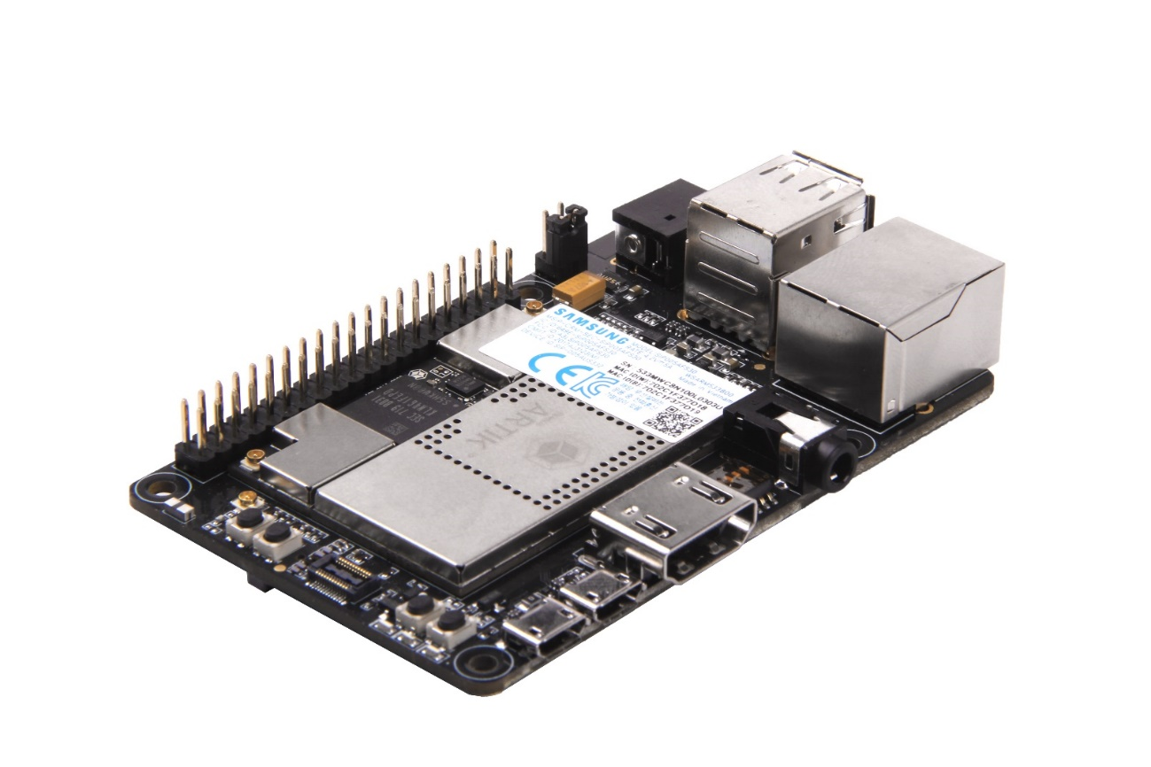

Figure . Preview of the ARTIK Pi

## Block diagram

Figure 2 shows the block diagram of the ARTIK Pi, if you want more information on the ARTIK 530 Series Module please consult the ARTIK 530 Series Module Datasheet.

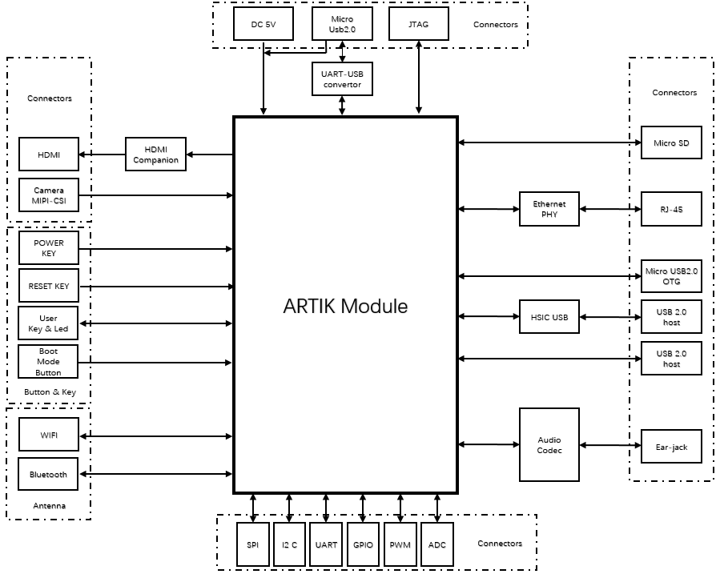

Figure 2. The block diagram of ARTIK Pi

## Mechanical Drawings

Figure 3 and Figure 4 show the Mechanical structure and size of the ARTIK Pi

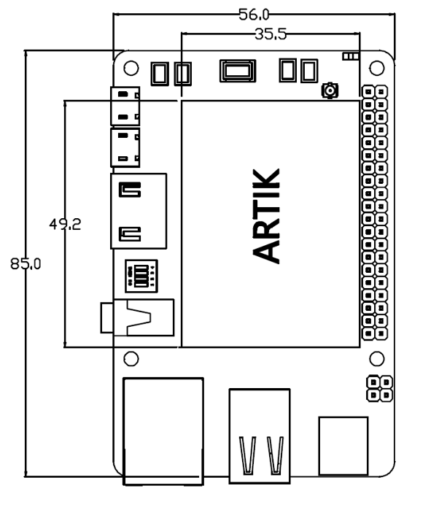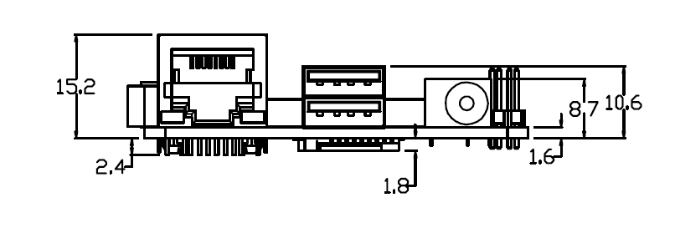

Figure 3. Mechanical Drawing ARTIK Pi all dimensions are in [mm]

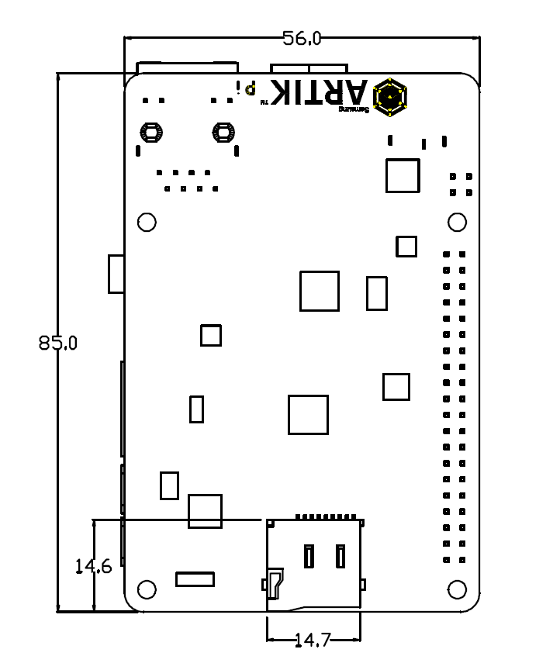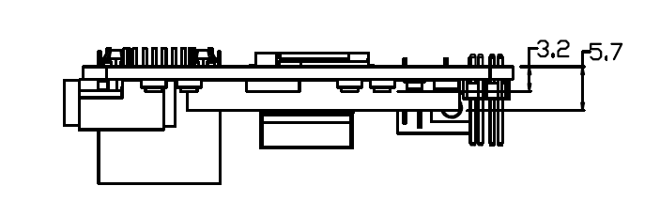

Figure 4. Mechanical Drawing ARTIK Pi all dimensions are in [mm]

# ARTIK 530 Series Module

The ARTIK Pi contains the ARTIK 530 Series Module. This section will describe some of the main features of this module. For more information on the ARTIK 530 Series Module please consult the ARTIK 530 Series Module datasheet.

## ARTIK 530 Series Module Specification

The ARTIK 530 Series Module is designed for IoT devices and it contains a lot of functions based on a Linux® system. Not only multimedia functions but also network functions for example 802.11 or ZigBee®. In addition the ARTIK 530 Series Module has mass storage functionality and its own security solution. Table 1 shows the main features of the ARTIK 530 Series Module that is part of the ARTIK Pi .

Table 1. Main Features of the ARTIK 530/530S Module

|  |  |
| --- | --- |
| **Processor** | |
| **CPU** | Quad core ARM® Cortex®-A9@1.2GHz |
| **GPU** | 3D graphics accelerator |
| **Media** | |
| **Camera I/F** | 4-lane MIPI CSI up to 5M  (1920x1080@30fps) |
| **Display** | 4-lane MIPI DSI and HDMI1.4a (1920x1080p@60fps) or LVDS (1280x720p@60fps) |
| **Audio** | Two I2S audio input/output |
| **Memory** | |
| **DRAM** | 512MB/1GB DDR3 |
| **FLASH** | 4GB eMMC v4.5 |
| **Security** | |
| **Secure Element** | Secure point to point authentication and data transfer |
| **Radio** | |
| **WLAN** | IEEE 802.11a/b/g/n, dual band SISO |
| **Bluetooth**® | 4.2 (BLE+Classic) |
| **802.15.4** | ZigBee®/Thread |
| **Power Management** | |
| **PMIC** | Provides all power of the ARTIK 530 Module using on board bucks and LDO’s |
| **Interfaces** | |
| **Ethernet** | 10/100/1000Base-T MAC (External PHY required) |
| **Analog and Digital I/O** | GPIO, UART, I2C, SPI, USB Host, USB OTG, HSIC, ADC, PWM, I2S, JTAG |

# ARTIK PI

Figure 5 and Figure 6 show the overall preview of the ARTIK Pi's TOP and BOTTOM

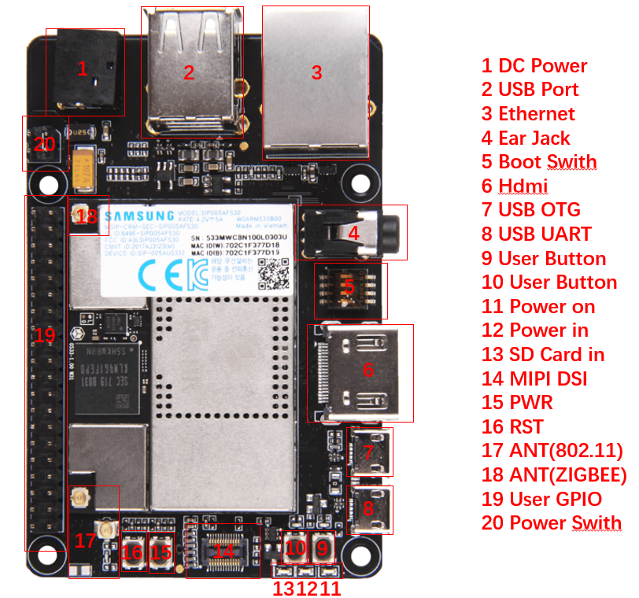

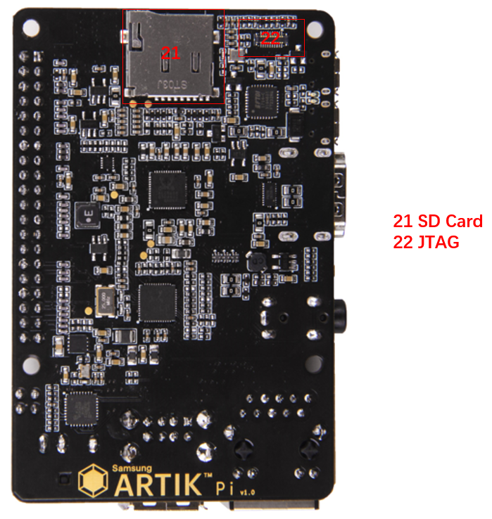

Figure 6. Bottom of ARTIK Pi

## Artik Pi Boot mode Configuration

This section describes the various boot modes that are supported on the ARTIK Pi. Table 2 and Figure 7 show how to manipulate SW402 and where SW402 is located on the Interposer Board to set the various booting options that are available on the ARTIK Pi.

When ‘eMMc 1st Boot’ is selected as a booting option, the system will first try to boot from eMMc, if this fails the system will search for an SD Card to boot from. If booting from the SD-Card also fails the system tries to boot from USB. When choosing the SD-Card booting option, the system starts with booting from SD, and if this fails will continue to try a USB boot. When USB is selected as the booting mechanism of choice, only a USB boot will be attempted.

Table 2. Boot option that can be set on the ARTIK Pi

| SW402 | eMMc 1st Boot | SD Card 1st Boot | USB 1st Boot |
| --- | --- | --- | --- |
| 1 | Off | Off | On |
| 2 | Off | Off | On |
| 3 | X | X | X |
| 4 | Off | On | X |

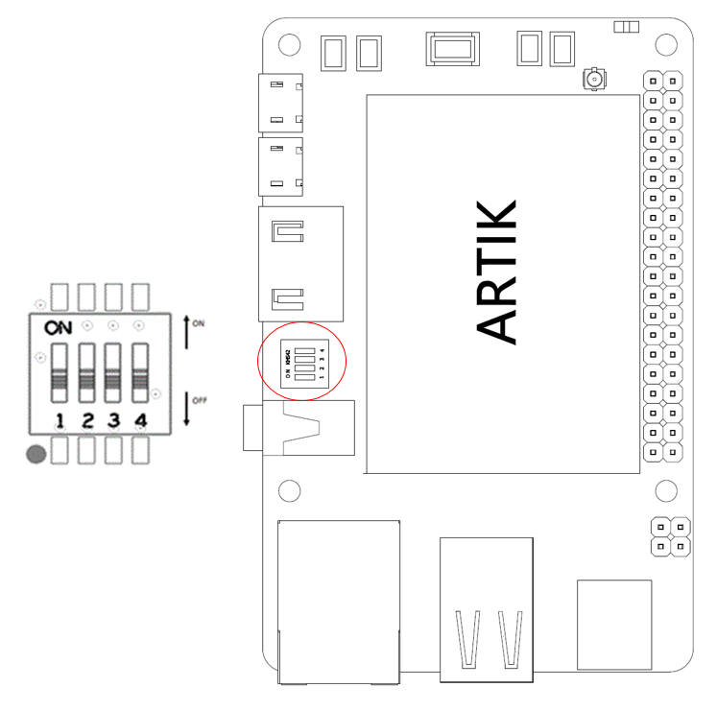

Figure 7. ARTIK Pi Booting Switch Location

## USB OTG

The ARTIK Pi has one USB OTG connector located as can be seen in Figure 8.

|  |  |
| --- | --- |
|  |  |

Figure 8. USB OTG Interface location on the ARTIK Pi

## HDMI 1.4a

The ARTIK Pi has one HDMI 1.4a connector located as can be seen in Figure 9. The following video formats are supported:

1. 480p/480i @59.94Hz/60Hz, 576p/576i@50Hz
2. 720p/720i @50Hz/59.94Hz/60Hz
3. 1080p/1080i @50Hz/59.94Hz/60Hz

|  |  |
| --- | --- |
|  |  |

Figure 9. HDMI 1.4a Interface location on the ARTIK Pi

## Ethernet

The ARTIK Pi has one Ethernet Interface, its location can be seen in Figure 10. The Ethernet Interface is based on 802.3az-2010 complying to the Energy Efficient Ethernet (EEE) standard. The maximum theoretical speed of the interface is 1000Mbps.

|  |  |
| --- | --- |
|  |  |

Figure 10. Ethernet Interface location on the ARTIK Pi

## Antenna

If 802.11 or Bluetooth® functionality is required, the antenna which is enclosed as part of the ARTIK Pi has to be attached to the ARTIK Pi as depicted in Figure 11.

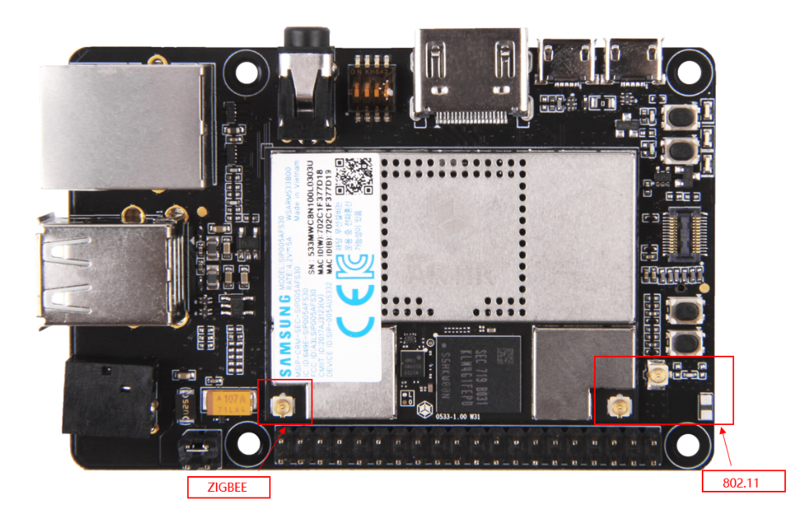

Figure 11. Antenna location on the ARTIK Pi

## Configuration of External Power Source

Through selection of the Jumpers JP1and JP2, the power source can be selected. When power is provided from a DC-5V Adapter , jumpers JP2 will be placed and 3-4 position will be connected.

When the jumpers JP1 are in the 1-2 position, the power is provided from the usb-uart

Figure 12 shows the default settings and how to switch between the settings. When the ARTIK Pi is used with an external power adapter make certain that you use a 5V-2.5A adapter with a 2.1x5.5mm plug.

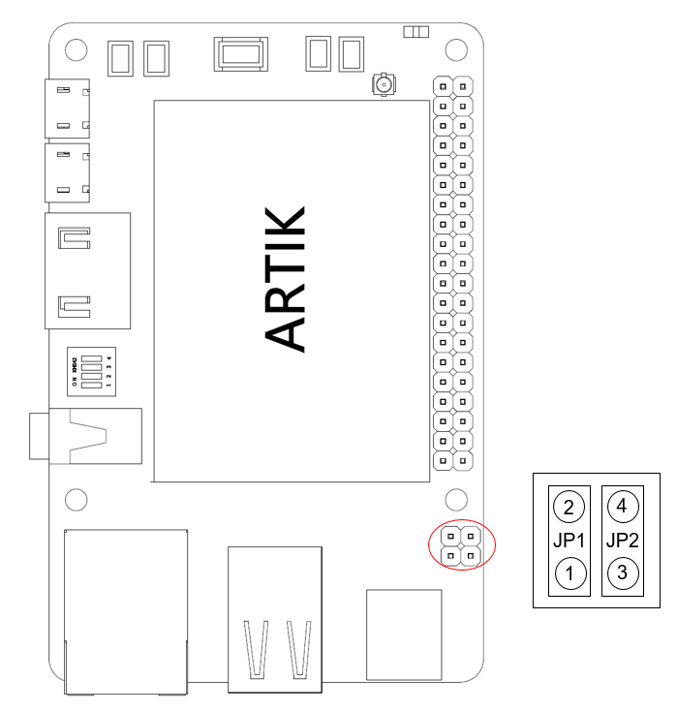

Figure 12. Jumper Interface locations JP1 or JP2 on Connectors

|  |
| --- |
| Warning : NEVER connect both at the same time! |

## SD-Card Interface

The ARTIK Pi has one SD-CARD interface supporting SD3.0 located as can be seen in Figure 13.

|  |  |
| --- | --- |
|  |  |

Figure13. SD-Card Interface location on the ARTIK Pi

## EarJack Interface

The ARTIK Pi has one 4 pin ear jack interface supporting stereo audio as can be seen in Figure 14.

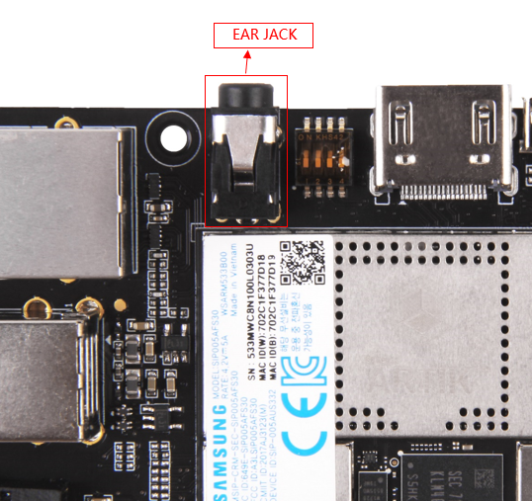

Figure14. Ear Jack Interface location on the ARTIK Pi

## MIPI CSI Interface

The ARTIK Pi has one MIPI CSI interface. The location of the MIPI CSI interface can be seen in Figure 15. The MIPI CSI interface can have a static resolution of 5M pixels or a dynamic resolution for video capturing of 1080P.

|  |  |
| --- | --- |
|  |  |

Figure 15. MIPI CSI Interface Location on the ARTIK Pi

## USB Host 2.0 Interface

The ARTIK Pi has two USB 2.0 Interface. The location of the USB 2.0 interface can be seen in Figure 16.

|  |  |
| --- | --- |
|  |  |

Figure 16 USB2.0 Interface location on the ARTIK Pi

## The Connector interface

The ARTIK Pi has one expansion connector that can be seen in Figure 17. This connector enables for expansion possibilities.

Figure 17. Expansion Connector Interface location on the ARTIK Pi

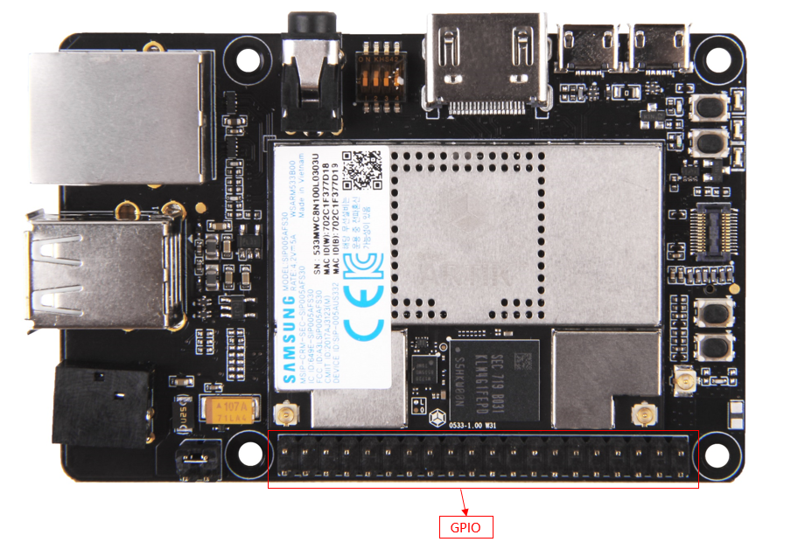

Figure 18 shows the expansion connector. In addition Table 3 show the pinout of the connectors with its meaning.

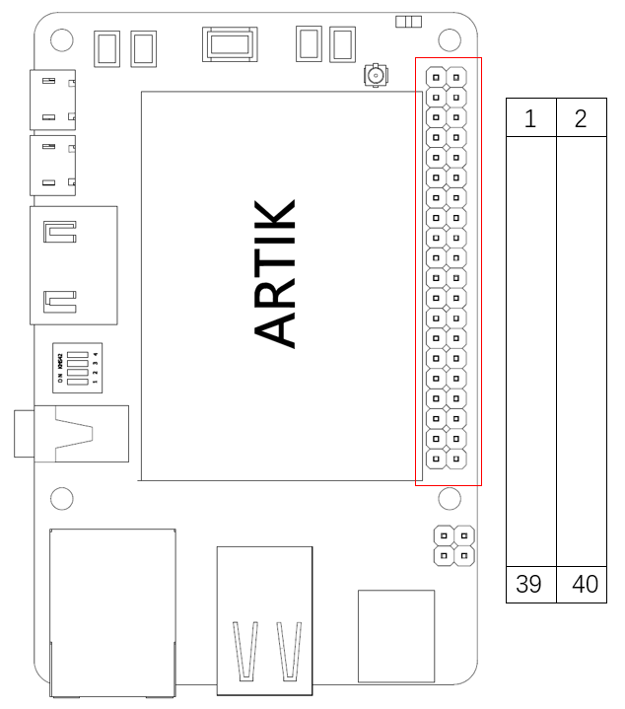

Figure 18. The expansion connector on the ARTIK Pi

Table 3. The pinout of the connectors with its meaning

| Pin Name | Pin Number | Pin Number | Pin Name |
| --- | --- | --- | --- |
| 3.3V | 1 | 2 | 5V |
| XI2C0_SDA | 3 | 4 | 5V |
| XI2C0_SCL | 5 | 6 | GND |
| XAGPIO0 | 7 | 8 | XUART0_TX |
| GND | 9 | 10 | XUART0_RX |
| XGPIO0 | 11 | 12 | I2SBCK1 |
| XGPIO1 | 13 | 14 | GND |
| PWM2 | 15 | 16 | XGPIO2 |
| 3.3V | 17 | 18 | XGPIO3 |
| XSPIO_MOSI | 19 | 20 | GND |
| XSPIO_MISO | 21 | 22 | PWM0 |
| XSPIO_CLK | 23 | 24 | XSPIO0_CS |
| GND | 25 | 26 | XGPIO4 |
| NC | 27 | 28 | NC |
| XGPIO9 | 29 | 30 | GND |
| XGPIO6 | 31 | 32 | XGPIO7 |
| XGPIO8 | 33 | 34 | GND |
| I2SLRCLK1 | 35 | 36 | XADC0 |
| XADC1 | 37 | 38 | I2SDIN1 |
| GND | 39 | 40 | I2SDOUT1 |

# ARTIK Pi Booting

This section will describe how to start working with your ARTIK Pi Development Environment by setting up a serial connection on your development PC and booting up the ARTIK Pi Development Environment.

## Serial Port Connection

As a first step we will select a serial console to communicate with the ARTIK 530 Module that is located on the ARTIK Pi Development Environment. You can use a typical Linux® serial console as depicted in Figure 19, using the serial connector. If your PC does not have a serial port, use the micro-USB B serial cable instead. To use the serial USB cable you need to install the associated device driver. Figure 20 depicts the USB serial cable and where it is hooked up to the ARTIK Pi.

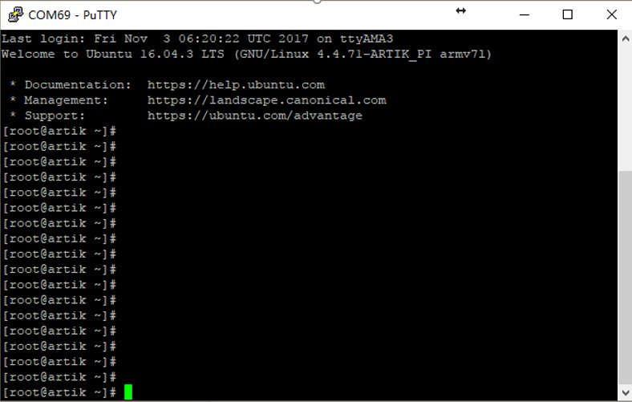

Figure19. Typical Linux® Serial Console

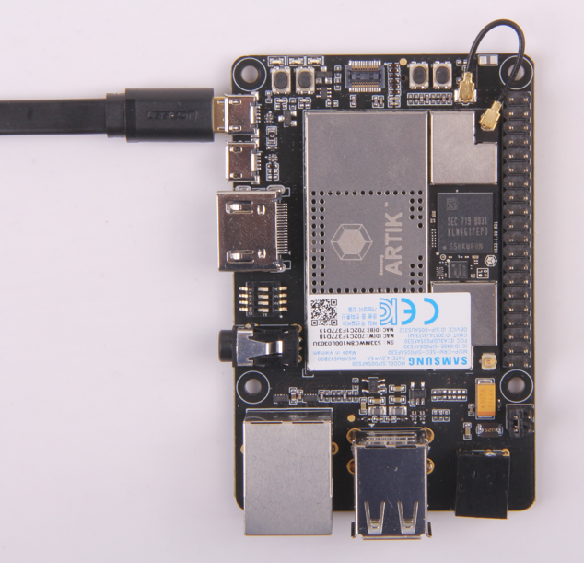

Figure 20. USB Serial Cable hooked up to the Platform Board

## Terminal Emulator Installation

Setting up a connection with the ARTIK 530 Module can be done in a wired or wireless manner. Here we choose to install PuTTY a free serial console. The software can be downloaded from <http://www.putty.org/>. Once downloaded go through the following steps:

1. Open the device manager on the control panel.
2. When using a PC install the USB to Serial driver. The driver can be found at the following location: (<http://www.ftdichip.com/Drivers/CDM/CDM21218_Setup.zip>). For other drivers please visit (<http://www.ftdichip.com/Drivers/D2XX.htm>).
3. Check the COM port number on your PC when you connect the USB serial cable. In our case the COM port allocated is COM9.

|  |
| --- |
|  |

1. Set the PuTTY configuration as follows:
   1. Set the “Serial line” as the COM port number found in step 3.
   2. Set the COM speed to "115200".
   3. Set the connection type to "Serial".
   4. Save the session under ARTIK-Pro.
2. Select your saved session and click the “Open” button.

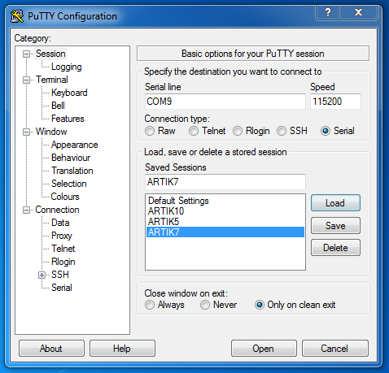

## Power on the ARTIK Pi

To power up the ARTIK Pi Development Environment you first have to connect the power adapter as shown in Figure 21. In addition make certain that the jumpers JP2 located on the ARTIK Pi are set in state with 3-4 position be connected Configuration of External Power Source section for details.

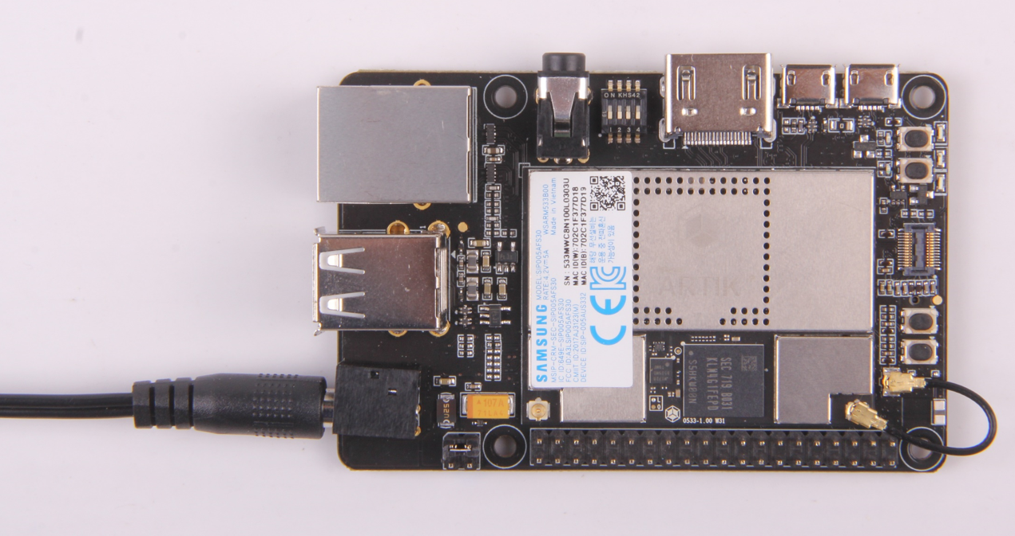

Figure 21 Connection Power adaptor with the ARTIK Pi

Turn on the power switch as shown in Figure 22.

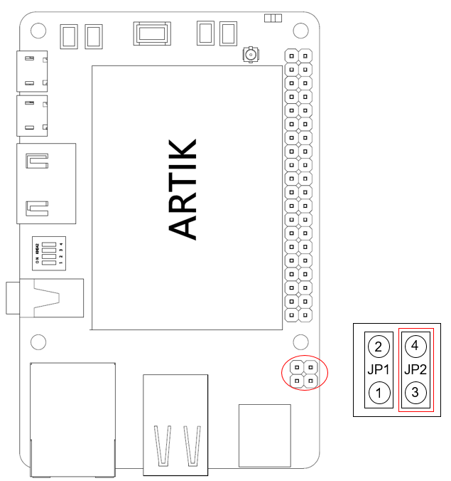

Figure22. Power switch location on the ARTIK Pi

Once the power switch is turned on, push the power button (S1), as depicted in Figure 23, for about 1 second. Once released the booting process will start and you should see booting messages from your console, using the serial connection that you previously established.

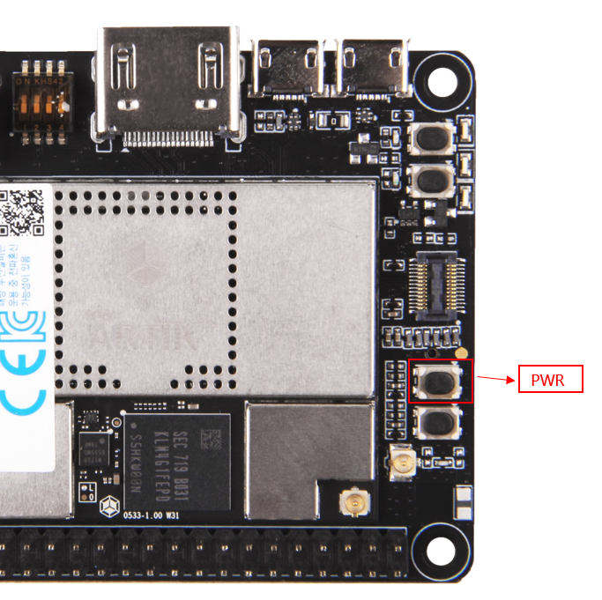

Figure 23. Power button location on the ARTIK Pi

# Legal Information

INFORMATION IN THIS DOCUMENT IS PROVIDED IN CONNECTION WITH THE SAMSUNG ARTIK™ DEVELOPMENT BOARD AND ALL RELATED PRODUCTS, UPDATES, AND DOCUMENTATION (HEREINAFTER “SAMSUNG PRODUCTS”). NO LICENSE, EXPRESS OR IMPLIED, BY ESTOPPEL OR OTHERWISE, TO ANY INTELLECTUAL PROPERTY RIGHTS IS GRANTED BY THIS DOCUMENT. THE LICENSE AND OTHER TERMS AND CONDITIONS RELATED TO YOUR USE OF THE SAMSUNG PRODUCTS ARE GOVERNED EXCLUSIVELY BY THE SAMSUNG ARTIK™ DEVELOPER LICENSE AGREEMENT THAT YOU AGREED TO WHEN YOU REGISTERED AS A DEVELOPER TO RECEIVE THE SAMSUNG PRODUCTS. EXCEPT AS PROVIDED IN THE SAMSUNG ARTIK™ DEVELOPER LICENSE AGREEMENT, SAMSUNG ELECTRONICS CO., LTD. AND ITS AFFILIATES (COLLECTIVELY, “SAMSUNG”) ASSUMES NO LIABILITY WHATSOEVER, INCLUDING WITHOUT LIMITATION CONSEQUENTIAL OR INCIDENTAL DAMAGES, AND SAMSUNG DISCLAIMS ANY EXPRESS OR IMPLIED WARRANTY, ARISING OUT OF OR RELATED TO YOUR SALE, APPLICATION AND/OR USE OF SAMSUNG PRODUCTS INCLUDING LIABILITY OR WARRANTIES RELATED TO FITNESS FOR A PARTICULAR PURPOSE, MERCHANTABILITY, OR INFRINGEMENT OF ANY PATENT, COPYRIGHT, OR OTHER INTELLECTUAL PROPERTY RIGHT.

SAMSUNG RESERVES THE RIGHT TO CHANGE PRODUCTS, INFORMATION, DOCUMENTATION AND SPECIFICATIONS WITHOUT NOTICE. THIS INCLUDES MAKING CHANGES TO THIS DOCUMENTATION AT ANY TIME WITHOUT PRIOR NOTICE. THIS DOCUMENTATION IS PROVIDED FOR REFERENCE PURPOSES ONLY, AND ALL INFORMATION DISCUSSED HEREIN IS PROVIDED ON AN “AS IS” BASIS, WITHOUT WARRANTIES OF ANY KIND. SAMSUNG ASSUMES NO RESPONSIBILITY FOR POSSIBLE ERRORS OR OMISSIONS, OR FOR ANY CONSEQUENCES FROM THE USE OF THE DOCUMENTATION CONTAINED HEREIN.

Samsung Products are not intended for use in medical, life support, critical care, safety equipment, or similar applications where product failure could result in loss of life or personal or physical harm, or any military or defense application, or any governmental procurement to which special terms or provisions may apply.

This document and all information discussed herein remain the sole and exclusive property of Samsung.   
All brand names, trademarks and registered trademarks belong to their respective owners. For updates or   
additional information about Samsung ARTIK™, contact the Samsung ARTIK™ team via the Samsung ARTIK™   
website at [www.artik.io](http://www.artik.io).

Copyright © 2017 Samsung Electronics Co., Ltd.

All rights reserved. No part of this publication may be reproduced, stored in a retrieval system, or transmitted in any form or by any means, electric or mechanical, by photocopying, recording, or otherwise, without the prior written consent of Samsung Electronics.